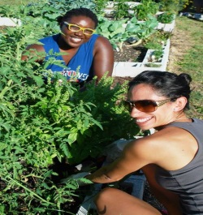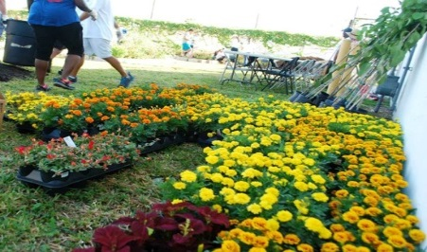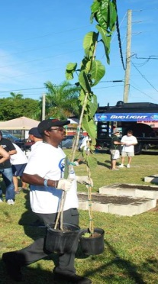 Give Some Green to Support Miami-Dade’s Green Movement
Litter Prevention
Research and experience prove that litter — intentional or unintentional pollution resulting from consumer waste products being carelessly handled or improperly disposed — attracts more litter. A clean community, by contrast, discourages littering and raises local living standards and quality of life.
Waste Reduction
At the point of purchase or use, consumers have the opportunity to consider a product, its packaging, how it is constructed, whether it can be reused or recycled, and whether it is made from recycled materials. By choosing recycled, recyclable or reusable products, we can extend the functional life of a product and divert it from the landfill. Purchasing recycled products also helps by creating a market for the recycled material, "completing the loop." Consumer demand is a powerful factor affecting the waste stream, and our decisions make a huge difference.
Beautification
Our organization's mission revolves around a core belief that beauty is a silent but powerful force that makes communities safer, healthier and more livable. "Beauty" is in our name, it’s the result of everything we do and it's what our organization is all about - citizens, government and businesses uniting to create better communities and contributing to a more beautiful world. We know that when a community and its residents unite with beautification as a common purpose, transformations occur not only in the physical surroundings, but in the hearts and minds of everyone involved.

